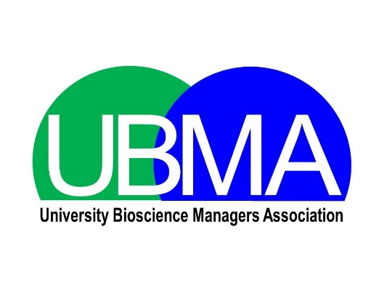

HE Bioscience Technician of the Year 2019
Application Form

Completed forms should be submitted by email to (rosie.wakeham@rsb.org.uk) by noon on Friday 11th January 2019

- Candidate details
Please note that all applications will be made anonymous before judging. The name on your application and department will be anonymised. The name and department of the individual providing institutional support for your application will also be anonymised.

First name |  | Surname
Other name |  | Title
Job title
Department
Institution
Address | Postcode:
Work tel.
Email
Bullet point career and education history

- Institutional support for the application

I confirm that the information provided in this form is accurate and that evidence exists to support all claims made about the applicant. An electronic signature will be accepted as proof of institutional sign-off.

Signed
Print name
Position
Date
Contact Address | Postcode:
Work telephone
Email
Statement of commendation (max 150 words)

- Application statement
This section is to be completed by either the candidate or sponsor. In not more than 400 words (and one optional image, data table or graph) please outline, with evidence (references are not included in the 400 word limit), how the candidate displays one or more of the following criteria:
- Applying professional technical knowledge and expertise
- Acquiring & effectively applying personal/professional development
- Making a positive impact and inspiring others
- Demonstrating leadership & collaboration
- Delivering innovation and efficiency

Finally, please tell us how you heard about the HE Bioscience Technician of the Year Award:

