How to make an articulated hand
Introduction
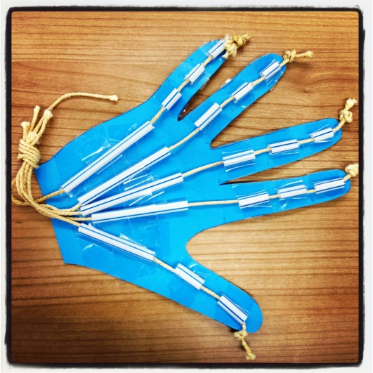
This activity combines a fun craft activity with hand anatomy. The anatomy covered is the bones (phalanges and metacarpals) and the tendons, by building the articulated hand from cardboard, string and straws visitors will gain a better understanding of how the hand functionally works.
Equipment
- Straws
- Cardboard
- String
- Sticky tape
For decoration (not essential):
- PVA glue
- Glitter
- Felt tips

Instructions
- Place your hand on a piece of thin cardboard and draw around it.
- Cut this out to make your hand shape.
- Get a chopping board or a really thick wad of newspaper and use a ruler and a pair of closed scissors to gently score lines where you want the fingers and thumb to bend.
- The "bones" are straws cut into sections. Lay a straw along each finger and cut pieces that fit inside the score lines.
- You will need 3 short pieces for each finger and a longer piece that reaches almost to the wrist.
- Use PVA or sticky tape, to stick all the straw pieces in place.
- Cut 5 lengths of thread or fine string that is roughly twice the length of the hand. When the glue is dry (or sticky tape attached) - thread each piece from the wrist to the fingertip through the straws pieces on each finger - it's fiddly but it should slip through easily.
- When all 5 strings are in place carefully tie knots in the fingertip ends. Put a dot of glue on the knots or tape down to the top of the fingertip straws.
- There you have it - articulated hands to amaze and probably scare friends when they least expect it.
- To make your articulated hand even more amazing and unique you can decorate it with felt-tips or for an extra glitzy effect why not cover with glitter?

